Project Name - Traffic simulation

**Author**: Type your name  
**Date**: 3 October 2022

**Description**

A program that simulates traffic using swing GUI, event handlers, listeners  
and incorporates Javaʼs concurrency functionality and the use of threads. The program  
first prompts for the number of column and row roads and initial cars. It then creates a  
canvas and allows the the traffic simulation to be started, paused, stopped and  
additional cars to be added.

**Project Structure**

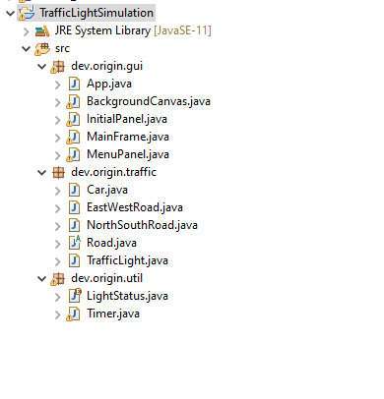

**UML Diagram**

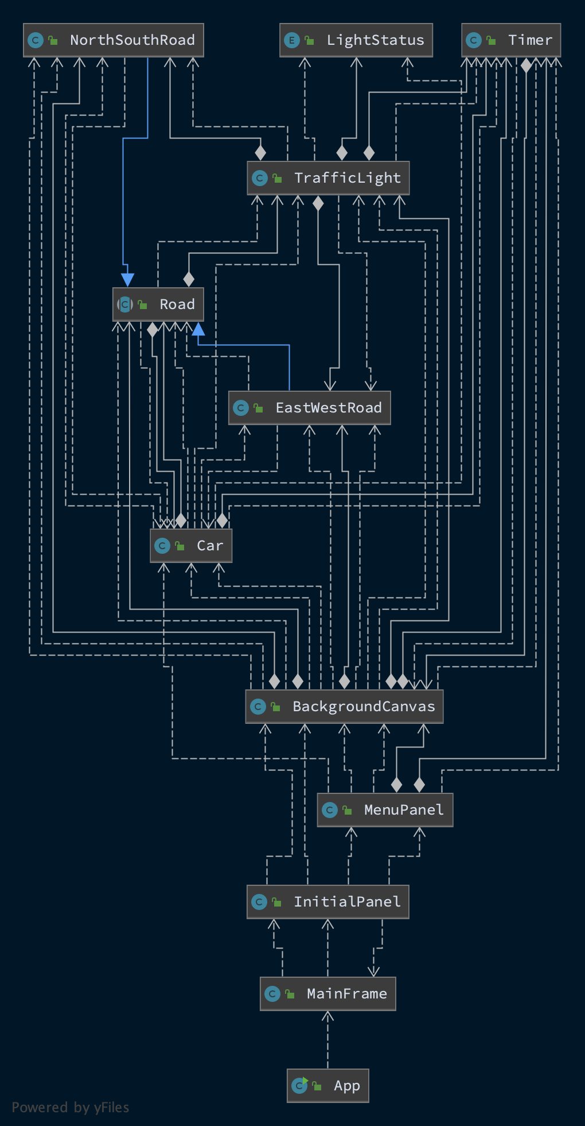

**Running this program**  
This program was developed on Eclipse IDE for Java Developers.

The only requirement for this program is to install Eclipse IDE on your machine.

To run this program, First open project on your Eclipse, then simply press CTRL+F11 on your keyboard or click Run button on your Eclipse IDE .

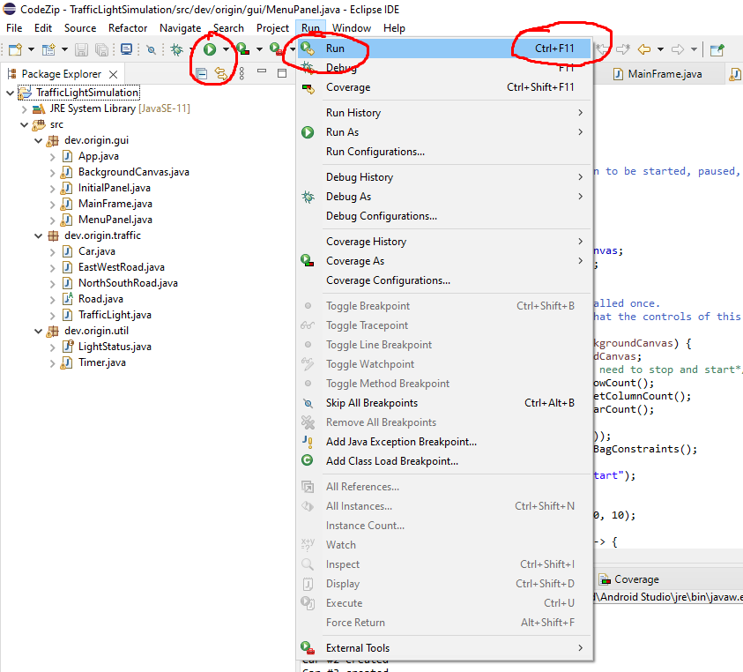

**Testing the Program**

The following sections will test the program's functionality to start various simulations,pause and stop them.

-select row and column of intersection and car count

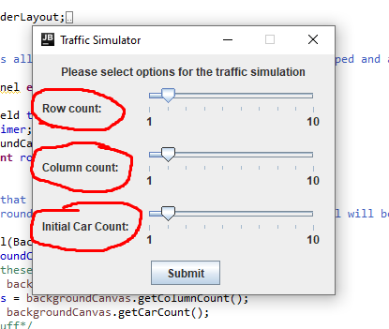

-Test1

The first test case will simply test the programs ability to start a traffic simulation with 2row roads and 2 column roads and 2 cars. These are the default options of the initial panel.

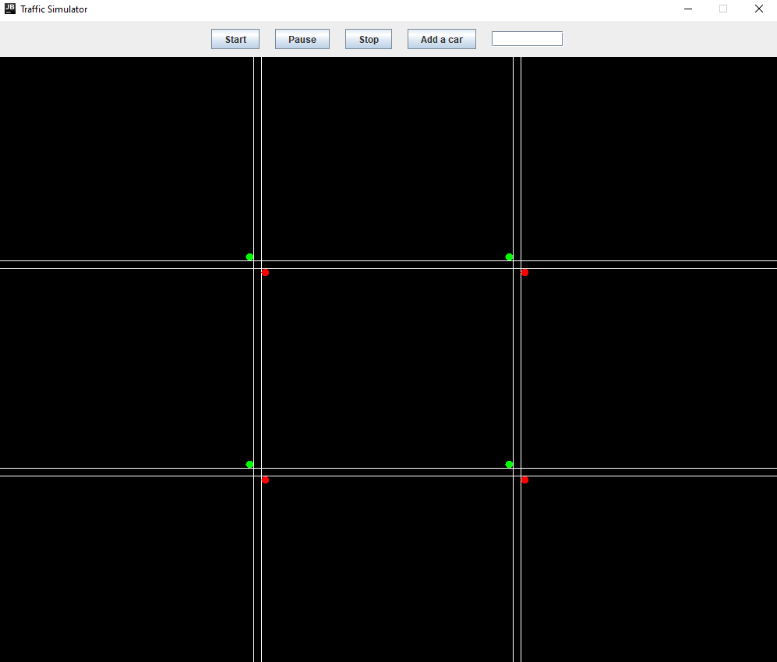

-Test2  
This test will test the ability of the program to start.

After pressing "Start, the timer will begin counting and every second the cars will move (unless they are at a red light).

The cars will move a random amount that is set in their constructor.

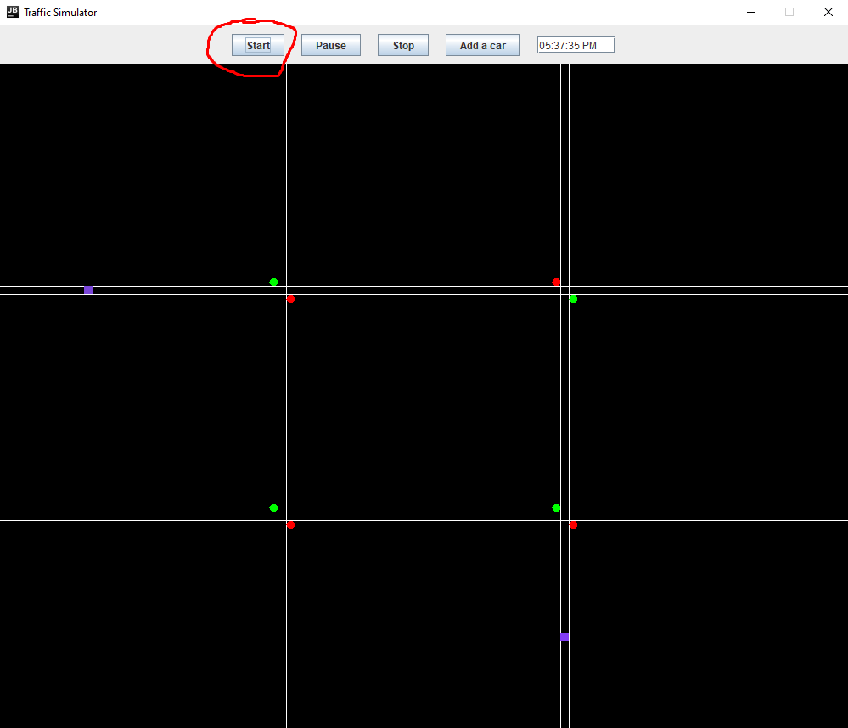

-Test3  
The pause is a boolean inside the timer object that is passed to all Threads.

This test case shows that when the "pause" is set to true by the JButton, all worker pause.

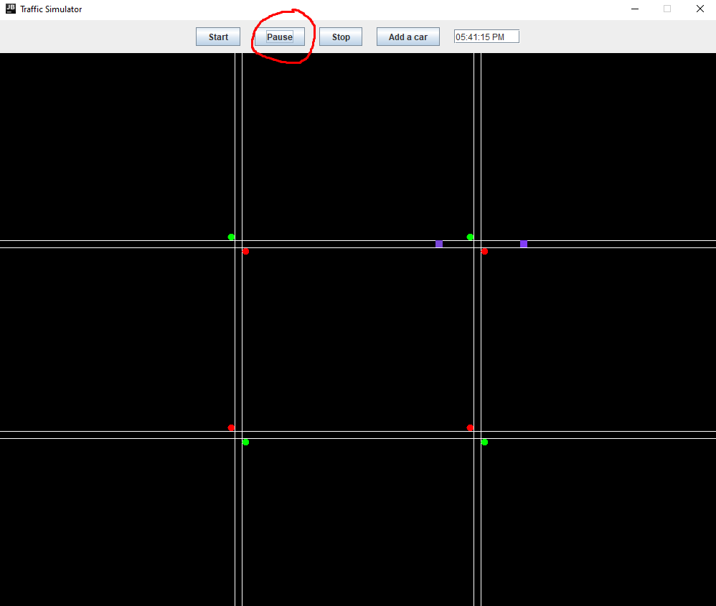

-Test 4

The Stop button replaces the JPanel that is being drawn to with a new one with matching starting conditions of the previous one.

The cars are still randomly placed.

This test case will test that Stop does create a new canvas and it will also test add new random cars using the "Add a car" JButton.

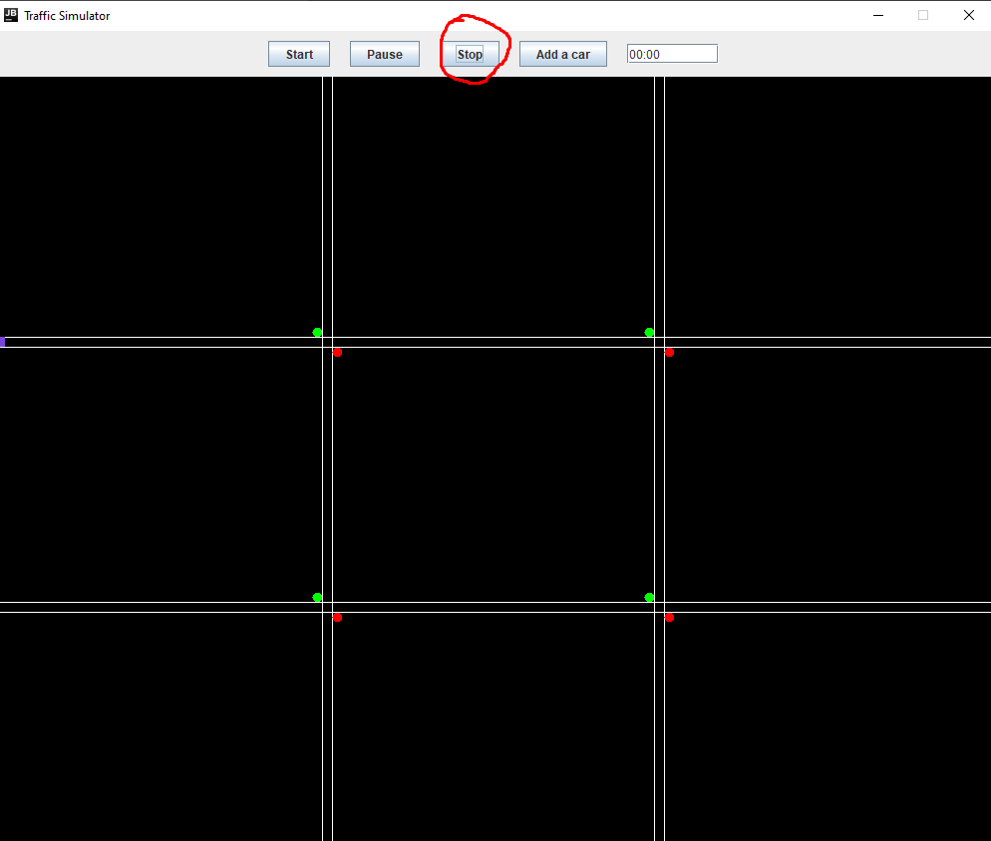

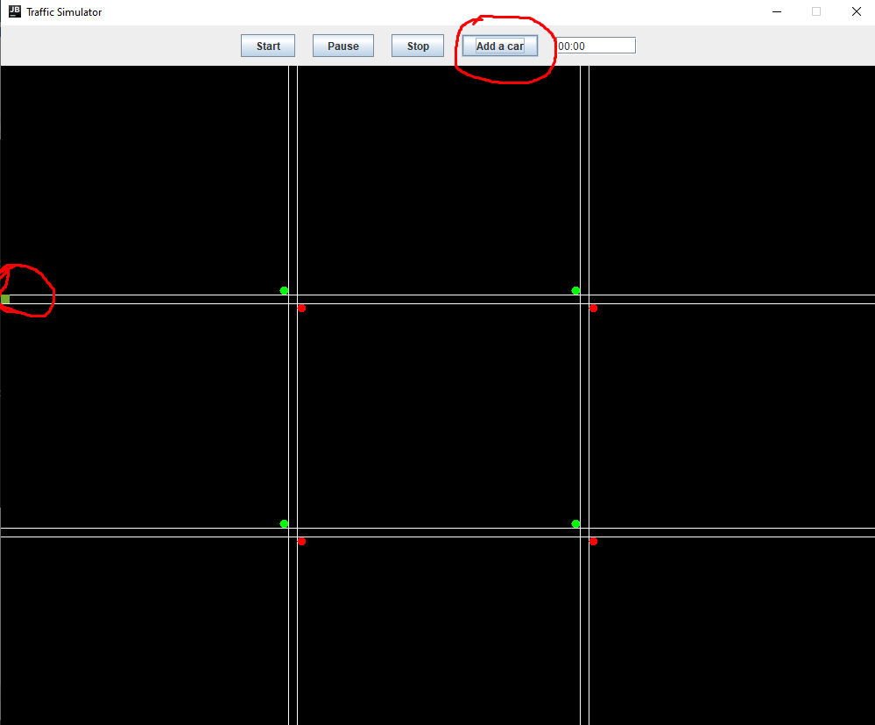

**Conclusion**

You can add text here